***Challenge 13***

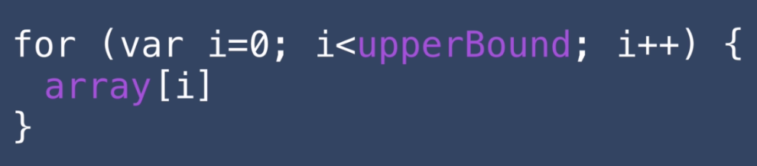

Show post title in console window

**Solution:**

**Home.ejs:**

<% for (var i = 0; i < posts.length; i++) { %>

<% console.log(posts[i].title); %>

<% } %>

**Complete Solution:**

<%- include('partials/header'); -%>

<h1>Home</h1>

<p><%= startingContent %></p>

<% console.log(posts); %>

<% for (var i = 0; i < posts.length; i++) { %>

<% console.log(posts[i].title); %>

<% } %>

<%- include("partials/footer"); -%>